Name:
Easier
Harder
Easier
1 | 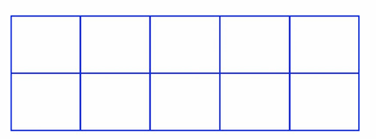  Shade $\frac{3}{5}$ of the shape. | Simplify this fraction:  $\frac{15}{20}$ | 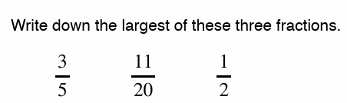 | Calculate:  $\frac{1}{3}$ + $\frac{2}{5}$ =
2 | Write down a fraction that is equivalent to $\frac{2}{3}$. | 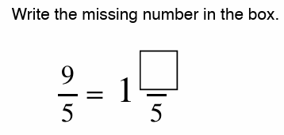 | 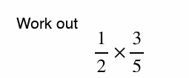 | 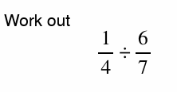
3 | Write down the ratio of squares to circles in its simplest form.  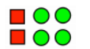 | Simplify the ratio 6:10 | 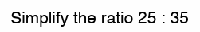 | 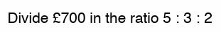
7 | What is 20% of £300? | I am getting a 10% pay rise. If I currently earn £450 a week, how much will I get each week after my pay rise? | I am getting a 15% pay rise. If I currently earn £450 a week, how much will I get each week after my pay rise? | In a sale, a pair of trainers is reduced by 20%. If they are currently priced at £80, what will they cost in the sale?
 | RECALL
 | 425 + 699 | 748 - 487 | Simplify:  4c + 3d -c | Expand the brackets:  3(y + 7) =
 | 17 x 21 | 453 $÷$ 5 | Solve:  3 + 2x = 15 | Factorise:  4a² – 2a
 | Write 6.2 x 10⁵ in ordinary form. | Simplify:  12⁶ $÷$ 12²= | The sweets in these bags are red or green. Circle the bag where it’s impossible to choose a red sweet from?  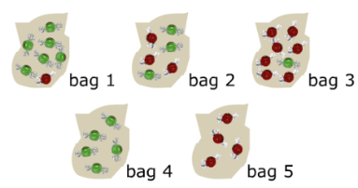 |  | If the 4 cards are placed face down on the table, if I choose a card what is the probability of choosing an M?  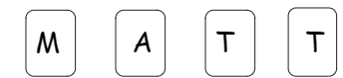
 | Calculate -16 + 5 = | 2 + 3 x 4 = | What is 10% of £35? |  | Add 34.67 and 532.3

